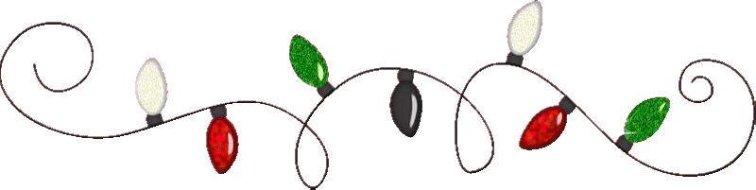
Caruthers Chamber of Commerce
Christmas Light Parade Application
Friday December 5, 2025

Individual/Organization Name: ________________________________________________________________________________

YOU MUST HAVE LIGHT ON YOUR ENTRIES
____1. PLEASE NO STOPPING DURING PARADE, KEEP MOVING FORWARD
____2. ENTRIES WILL BE GIVEN NUMBERS ON THE NIGHT OF THE PARADE AS YOU CHECK IN
____3. LINE UP WILL TAKE PLACE AT CARUTHERS ELEMENTARY SCHOOL. ALL ENTRIES MUST BE AT THE SCHOOL BY 5:15PM
____6. THIS IS A FAMILY FRIENDLY EVENT. DRUGS AND ALCOHOL ARE PROHIBITED
____7. NOTHING SHALL BE THROWN FROM THE ENTRIE. YOU MAY WALK AND HAND IT TO THEM.
____8. NO SANTA CLAUS ON FLOATS…WE HAVE ONE IN THE PARADE
LIABILITY RELEASE: In consideration of being permitted to participate in the Caruthers Chamber Christmas Parade and Winter Festival, I agree to assume all risk connected therewith and will make no claim against, sue, or attach the property of the Caruthers Chamber of Commerce, Caruthers District Fair, Its employees, volunteers, or committee members. I hereby release the Caruthers Chamber of Commerce and Caruthers District Fair from all damages or injury resulting from my participation in the Christmas Parade and Winter Festival.

NAME__________________________________________________ DATE__________________________________________
e-mail address: ___________________________________________ PHONE #: _______________________________________

Mail form to: Eric Hamlin 1776 Ave C • Kingsburg Ca, 93631
Or email to esejham@netzero.com • Turn in by November 29th

